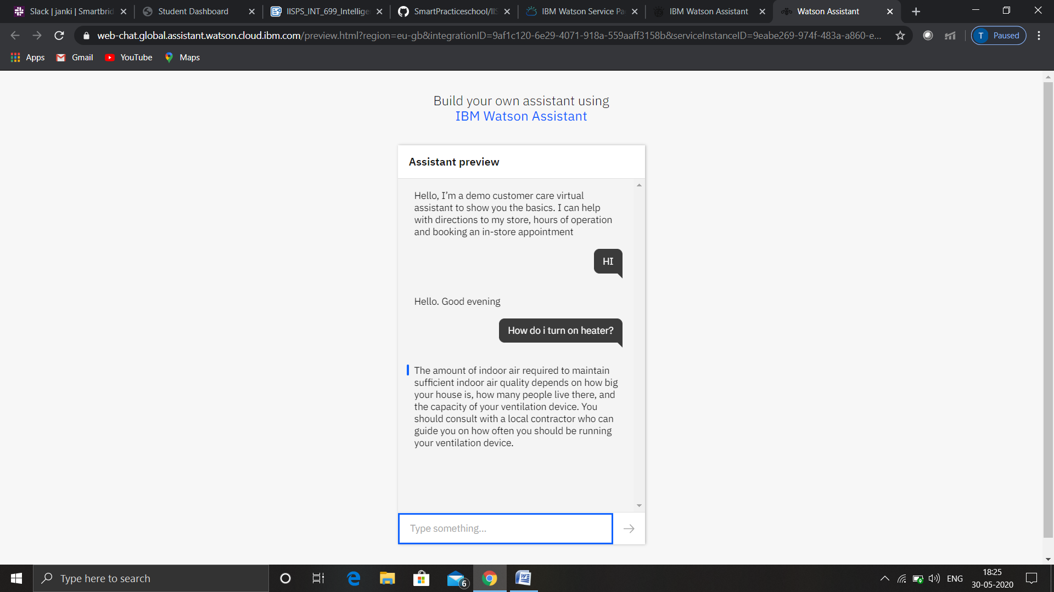

Link for chatbot:- https://web-chat.global.assistant.watson.cloud.ibm.com/preview.html?region=eu-gb&integrationID=9af1c120-6e29-4071-918a-559aaff3158b&serviceInstanceID=9eabe269-974f-483a-a860-e5c5cd4c38c3